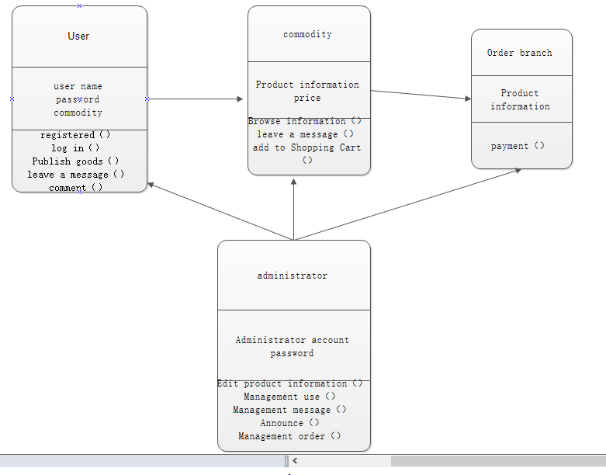

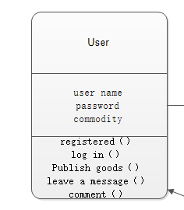

User registration login class:

Attribute: the name selected by the user（user name）, the password set by the user（password）

Method: used to log in（log in） to the website to post products （publish goods）and comments（comment）

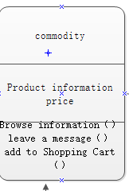

Commodity information class

Attribute: information of the product（product information）, the price at which the product is sold（price）

Method: The user selects his favorite item（browse information）, the user communicates with the seller（leave a message）, and the user joins his shopping cart(add to shopping cart).